**FISH 458/558 – Fisheries Population Dynamics**

Take-home Midterm Exam

**EXAM IS DUE BY 11:59PM on April 9, 2024**

**Instructions**: This take-home part of your midterm exam is worth a total of 45 points. This exam is for both 458 and 558 students. You may draw upon your notes or any other written supporting material. **You may NOT consult with other students (past or present) or other people.** Please provide sufficient depth in your answers that convey your grasp of the topic. **This exam is NOT to be shared with any other individuals or students (current or future)**. Submit your exam as a Word document via Canvas by the due date and time. I am available for answering any questions you may have! Good luck!

**Formatting guidelines:**

* Overall
  + Include an appropriate header for your document
  + CLEARLY identify your answers to the questions and include the correct question number
  + Write in a manner that would be suitable for a scientific article (i.e., write professionally!)
  + Avoid grammatical errors 🡪 Proofread your answers!
  + Include your R code as an appendix to the exam (i.e., at the end), instead of having separate chunks of code for each question/section.
* For all figures:
  + make sure that the X and Y limits are appropriate,
  + make sure the size and scale of your plots are appropriate (i.e., no squashed or squeezed figures),
  + label axes and include units,
  + include a legend where appropriate (e.g., when plotting multiple lines), and don’t have the legend cover any part of your plot,
  + include an informative figure caption below the figure. (Note: multi-panel figures with a single caption will likely be useful for the diagnostic plots)
* For all tables:
  + include a table caption above the table

**QUESTIONS (45 points)**

1. Below are some results for an occupancy analysis of a terrestrial salamander (Table 1, Figure 1). Use the results to answer the questions. (8 pts)
   1. What conclusions can you make from Table 1 regarding the results of the study and the variables that are important? Explain your reasoning. (3 pts)
   2. How do the AICc, ΔAICc, and Weight columns in Table 1 relate to one another generally? (2 pts)
   3. What main conclusions can you make from the Figure and how does this relate to the Table? Explain your reasoning. (3 pts)
   4. Do these results (i.e., Table 1 and Figure 1) indicate how the occupancy changes with disturbance history? Why? (1 pt)

**Table 1**. Results of occupancy model selection for salamanders in a National Park. The models considered assume occupancy was either constant across sites ψ (.), or varied according to the sites’ previous disturbance history, ψ (dist). Detectability was modeled in four ways: it was constant across all surveys and sites p(.), it varied among surveys p(t), it varied across sites according to previous disturbance history p(dist), or it varied by both disturbance history and survey p(dist+t). Model selection was based on Akaike’s Information Criteria for small sample size (AICc), and Akaike weight (w).

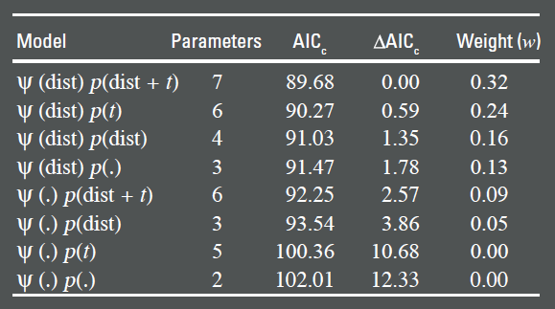

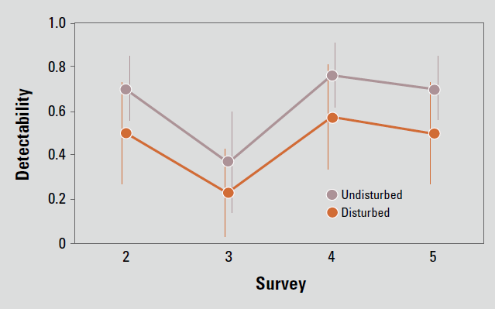

**Figure 1.** Estimates of detectability across surveys and among sites with different disturbance histories. The estimates are averaged across all possible models.

1. Develop predictive stock-recruitment relationships for the hypothetical Pacific sardine (*Sardinops sagax*) data contained in the file “**Exam_2_SRdata.csv”** (units are millions of fish for the recruits and kmt for the spawners). Use nonlinear least squares (the nls() function in R) to fit your models. For your candidate set of models, fit the **density-independent**, **Beverton-Holt**, and **Ricker** models to the data, and assume that the models have **multiplicative error**. Do the following (15 points):
   1. Generate a single plot that includes the observed data and the 3 predicted lines for each model (in different colors). (4 pts)
   2. Create a table that includes the estimated *a* and *b* parameters (and their standard errors) for each of the 3 models. Include also the estimated AIC and AIC differences (i.e., Δ or dAIC) for each model. [Note, you do not have to make the table in R if you don’t want to]. (4 pts)
   3. Present diagnostic plots for each model for assessing the normality and homogeneity of variance assumptions. Provide a written description of your conclusions and reasoning regarding the assumptions based on you plots. (5 pts)
   4. Based on your analysis, describe what the best SR model is for the dataset and why. (2 pts)
2. Conduct yield per recruit (YPR) and spawning stock biomass per recruit (SBPR) analyses for a population of rainbow trout in Blue Lake, Sitka, Alaska. Your goal is to determine potential biological reference points (BRPs) to be used in management decisions and to describe the tradeoffs among the different BRP options. Natural mortality is estimated to be M=0.26 for the population. You should assume that 50% of fishing and natural mortality occur before spawning, and that there is no plus group. Using the **“Exam2_trout data.csv”** data (also in Table 2), answer the following questions. (20 pts)
3. Use a YPR analysis to determine the estimates for Fmax and F0.1, and the associated YPR at each of those F values. Report the estimates. You will use function **ypr()** function from the *fishmethods* package for this. (2 pts)
4. Use a SBPR analysis to determine the estimates for F30% and F40%, and the associated spawning stock biomass per recruit at each of those F values. Report the estimates. You will use function **sbpr()** function from the *fishmethods* package for this. (2 pts)
5. Make a graph of *YPR vs. F* with all four reference points (Fmax, F0.1, F30%, F40%) identified using vertical lines. (4 pts)
6. Make a graph of *% of Max SPR vs. F* with all four reference points (Fmax, F0.1, F30%, F40%) identified using vertical lines. Recall that the “*% of Max SPR”* should range from 0-100% (4 pts)
7. Create a single table to summarize the results of your YPR and SPR analyses. For each of the four BRPs (Fmax, F0.1, F30%, F40%), you should present: the associated F value, the corresponding annual exploitation rate (u; calculate this using the equation from lecture 14, assuming this is a Type I, pulse fishery), YPR (in kg), percent of max YPR (i.e., YPR expressed as a percentage of the maximum YPR), the spawning stock biomass per recruit (in kg), and the spawning stock biomass per recruit as a percentage of the maximum spawning potential. (4 pts)
8. Based on your plots and table with your calculated values, discuss the tradeoffs in yield and spawning potential ratio that result from the four different BRP options (Fmax, F0.1, F30%, F40%). Which reference point would you recommend to a manager and why? (4 pts)

Table 2. Parameters for rainbow trout in Blue Lake, Sitka, Alaska.

|  |  |  |  |  |  |
| --- | --- | --- | --- | --- | --- |
|  | Age | | | | |
|  | 3 | 4 | 5 | 6 | 7 |
| Mean Length (mm) | 238 | 286 | 329 | 368 | 400 |
| Mean weight (kg) | 0.156 | 0.272 | 0.405 | 0.538 | 0.658 |
| Maturity | 0.29 | 0.77 | 0.96 | 1 | 1 |
| Selectivity | 0.61 | 0.92 | 1 | 0.6 | 0.6 |

1. Re-read the instructions and formatting guidelines. State whether you followed them.
2. How many hours did you spend on this exam? (1 pt)